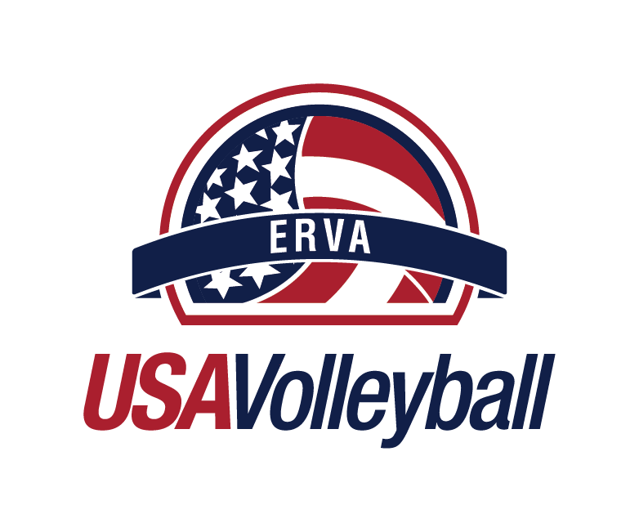

RETURN TO PLAY GUIDELINES
CLUB TEMPLATE 2020

DISCLAIMER – These guidelines are provided for general informational purposes only and are not intended as, or should be relied upon as, specific medical or legal advice. All participants are strongly encouraged to consult with qualified medical personnel and/or public health officials for medical advice. Also consult with federal, state and local orders and/or laws for legal considerations. If you use any considerations provided herein, you do so at your own risk and specifically release from any and all liability, USAV, the forty (40) Regions, and their directors, officers, employees, volunteers and agents in connection with your use of the enclosed guidelines. USAV and the Regions make no warranties or statements as to the completeness, reliability, and accuracy of the information contained herein.

- PURPOSE – The purpose of these guidelines is to create a comprehensive return to play plan for ERVA sanctioned activities at Browns Park Sand Court Facility in Spokane Valley that are compliant with federal, state, and local regulations. ERVA/USAV sanctioned activities include but are not limited to: tryouts, lessons, practices, scrimmages, camps, clinics, combines, showcases, or tournaments.

Until COVID-19 is either eradicated, a vaccine is developed, or a cure is found, there is no way to completely eliminate the risk of infection and as such USAV strongly encourages all participants to follow these recommendations as safety precautions.

ALL participants will be REQUIRED to sign a Waiver/Release for Communicable Diseases including COVID-19 & Agreement to abide by PROGRAMMING POLICIES PRIOR to ANY participation in ERVA/USAV Sanctioned Events.

The information in this document is not intended or implied to be a substitute for professional medical advice, diagnosis, or treatment, nor does USAV or its forty (40) Regional Volleyball Associations (Region(s)) assume any liability or responsibility for the recommendations provided herein.

- RISK CATEGORIES – Current volleyball activities are segmented into three types of risk categories:
  - Low Risk – Individual skill development (passing drills, blocking, hitting, setting, serving, general fitness, strength training) at home (backyard, driveway, in- home), alone or with household members and with owned and sanitized equipment.
  - Medium Risk – The above activities in public spaces alone or with household members; individual skill development with non-household members following the recommended physical distancing and sanitizing volleyballs.

  - High Risk – Individual skill development with non-household members not following the recommended physical distancing & not sanitizing volleyballs. Participating in any team or group play.

- RETURN TO PLAY GUIDELINES FOR PARTICPANTS AND SPECTATORS – Follow all guidelines when participating/spectating in any activities at Browns Park.

Before Activities
    - Be symptom free for at least 14 days prior to any activity. If you or anyone in your household experienced any of the following symptoms, we kindly ask you to please NOT attend league. Symptoms may appear 2-10 days after exposure to the virus. People with these symptoms or combinations of symptoms may have COVID-19:
      - Cough
      - Shortness of breath or difficulty breathing
    - Or at least two of these symptoms:
      - Fever
      - Chills
      - Repeated shaking with chills
      - Muscle pain
      - Headache
      - Sore throat
      - New loss of taste or smell
    - Stay home if you are sick or do not feel well.
    - Be aware of and disclose any potential close contacts with COVID-19 positive individuals.
    - Wash and sanitize your hands often.
    - Do not touch your face, eyes or mouth with unclean hands.
    - Practice social distancing regularly.
    - Wear a face mask to reduce exposure to airborne particles.
    - Cover your mouth and nose with a tissue or your elbow if you cough or sneeze.
    - Keep a list of people you have been in close contact with each day. Close contact would be time spent with another person, while not wearing a mask, where physical distancing was not able to be maintained and where the duration of contact was more than 15 minutes.
    - Schedules:
      - To view court availability for community use: https://www.evergreenregion.org/browns-park-sand-facility/
      - Browns Park League Participants: will be required to get play schedules on mobile device through https://erva.bracketpal.com/index/1 to limit groups gatherings on site to view a posted schedule.
        - Staff will be on site during Leagues to assist with any questions.

During Activities
    - Refrain from attending any activity if displaying any COVID-19 symptoms. If you or anyone in your household experienced any of the following symptoms, we kindly ask you to please NOT attend. Symptoms may appear 2-10 days after exposure to the virus. People with these symptoms or combinations of symptoms may have COVID-19:
      - Cough
      - Shortness of breath or difficulty breathing
    - Or at least two of these symptoms:
      - Fever
      - Chills
      - Repeated shaking with chills
      - Muscle pain
      - Headache
      - Sore throat
      - New loss of taste or smell
    - Comply with all permissible regulations approved for the venue.
    - Wash and/or sanitize your hands often.
    - Do not touch your face, eyes or mouth with unclean hands.
    - Refrain from contacting other participants and attendees (high fives and huddles).
    - Spectators:
      - Spectators will be limited to specified areas.
      - Please inquire with staff if you have questions.
    - League Match Procedures:
      - Home team, as designated by schedule, will pick up a sanitized volleyball from staff at designated BALL PICK UP table.
      - ALL Participants will be required to apply hand sanitizer before each match and after final match.
        - Sanitizer will be available for use
        - It is recommended participants bring hand sanitizer/wipes of their own.
      - Warm-Ups & Game Balls:
        - 1 game ball will be provided per court for teams to use for match play. No individual balls should be used during match play.
        - Individually owned volleyballs can be used for team warm-up only.
      - Serve/Receive Procedure @ beginning of match
        - Rock, paper, scissors at 6 feet social distance
      - Score keeping procedures
        - Teams will keep score during matches by calling out score before every serve. NO FLIP SCORES will be used.
        - Designated home team will report match scores at the end of the match.
      - Court switches, every 7 points played:
        - Players will go outside the pole to the right versus under the net.
        - Be aware of players/spacing on court next to you
    - End of Match Procedure:
      - Home Team (as designated by schedule) will report match scores and turn in used match volleyball to staff at designated SCORE REPORTING/USED BALL TABLE.
    - Practice social distancing as often as possible.
    - Wear a face mask while at the venue when social distancing isn’t possible in between matches
    - Cover your mouth and nose with a tissue or your elbow if you cough or sneeze.
    - Bring hand sanitizer and sanitizing wipes.
    - Do not share drinks or water bottles
    - Properly dispose of your personal drinking cups, bottles, or utensils used.
    - Keep a list of people you were in contact with during the activity.

After Activities
    - Wash/sanitize your hands after last match.
    - Do not touch your face, eyes or mouth with unclean hands.
    - Monitor your health and report any symptoms after every activity.
    - Practice social distancing as often as possible.
    - Wear a face mask when possible to reduce exposure to airborne particles.
    - Cover your mouth and nose with a tissue or your elbow if you cough or sneeze.
    - Wash/sanitize all gear, uniforms and apparel used during the activity.

- RETURN TO PLAY GUIDELINES FOR EVENT STAFF- Follow all CDC, federal, state and local guidelines when participating in any activities.

Before Activities
    - Record temperature & time in prior to beginning on employee time sheet.
    - Stagger match start times to space out participant’s entry.
      - 30 min time gap between waves to allow for participant change over
    - Require all participants to sign Communicable Disease Waiver & League Policy Acknowledgement form prior to playing first match.
      - Verify that venue staff are symptom free before participating in any activities.
        - All staff will have their temperature checked prior to beginning duties.
        - Staff will answer the following questionnaire:
          - Have you or anyone in your household experienced any of the following symptoms, we kindly ask you to please NOT attend league. Symptoms may appear 2-10 days after exposure to the virus. People with these symptoms or combinations of symptoms may have COVID-19:
            - Cough
            - Shortness of breath or difficulty breathing
          - Or at least two of these symptoms:
            - Fever
            - Chills
            - Repeated shaking with chills
            - Muscle pain
            - Headache
            - Sore throat
            - New loss of taste or smell

- Enforce hand washing/sanitizing procedure before/after each match.
- Provide hand sanitizing station for participants and spectators
- Establish social distancing protocols.
  - Utilize designated areas for team check-in, score reporting, equipment management, customer service with social distancing procedures in place.
- Display signage clearly outlining the venue’s COVID-19 policies
  - Social Distancing Signage
  - Designated Area Signage
    - Team check-in, score reporting, equipment management etc.
  - League Policies
  - Spectator Policies
  - Restroom Policies

During Activities
- Enforce social distancing requirements as needed to participants and spectators.
- Regularly sanitize commonly touched surfaces during activity.
  - Pads, tables, chairs, etc.
    - Disinfectant procedure
  - Volleyball sanitizing procedures
    - During & After use
- Remove anyone from an activity if they exhibit any COVID-19 symptoms.
- Use hand whistles as opposed to regular whistles if necessary.
- Enforce hand washing/sanitizing procedure before/after each match.

After Activities
- Create no touch procedures for trophy, medal & award distribution
- Sanitize all surfaces and volleyballs that were used during activities in accordance with outlined staff disinfect procedures.
  - Pads, antenna, tables, chairs, rakes etc.
    - Disinfectant procedure
  - Volleyball sanitizing procedures
    - During & After use
- Record and sign employee equipment cleaning verification sheet
- Record time out on employee time sheet

- COVID-19 CONTRACT TRACING & NOTIFICATION–The Spokane Regional Health Department has been notified of the above protocol/guidelines. They are aware volleyball leagues, practices and tournaments will be taking place at Browns Park.

If necessary, SRHD will contact the Evergreen Region Volleyball Association if they need participant information for contract tracing & notification purposes.

The Evergreen Region Volleyball Association will keep logs for a minimum of 30 days of the following:
- Participant Attendance Logs from Region Hosted League
- Staff Log
- League Play Schedules
Spokane Regional Health Department contact information:
Phone: 509-324-1500
Website: https://srhd.org/covid19

- ADDITIONAL RESOURCES
- Latest Information from the White House on COVID-19: https://www.coronavirus.gov/
- Link to the President’s Opening Up American Again Guidelines - https://www.whitehouse.gov/openingamerica/

- CDC Guidance for Large Community Events and Mass Gatherings: https://www.cdc.gov/coronavirus/2019-ncov/community/large- events/index.html
- CDC Guidance for Cleaning and Disinfection of Community Facilities: https://www.cdc.gov/coronavirus/2019- ncov/community/organizations/cleaning-disinfection.html
- CDC Guidance for Cleaning and Disinfecting Your Facility: https://www.cdc.gov/coronavirus/2019-ncov/community/disinfecting-building- facility.html
- CDC Guidance for Visiting Parks and Recreational Facilities: https://www.cdc.gov/coronavirus/2019-ncov/daily-life-coping/visitors.html
- CDC Guidance on Coronavirus and Travel in the US: https://www.cdc.gov/coronavirus/2019-ncov/travelers/travel-in-the-us.html

