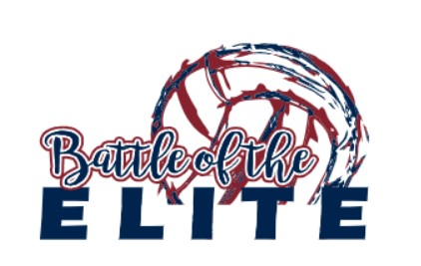
Battle of the Elite U-14
January 21, 2024
Warden School District
101 W Beck Way, Warden, WA 98857

Tournament Director: Michael De Hoog, 509-760-5475

Times: Gyms will be open at 7:00 am. Coaches meeting will be at 7:30 am. Play will begin at 8:00 am.

Pool Play: Warm-ups for the first two rounds will be five minutes and three minutes for the remaining rounds. Serving must be included within your warm-up time. We do ask that we keep the pace of play moving, but please use discretion. Number 1 seeds do not have a break from playing and officiating until the fifth round of pool play.

Bracket Play: Play will begin shortly after pool play is finished and the brackets are set. Sets will be best of three with no cap. Four teams will go to the Gold bracket and four teams will go the Silver bracket and four teams will go to the Bronze bracket. Prizes will be given for 1st place in each bracket. Check in with tournament director before leaving to secure that all officiating assignments are covered.

Team Areas: Team areas will be designated. Any of you that have hosted tournaments understand what clean up can be like when the day is done. Please communicate with your parents and players to clean up after themselves and let myself know of any spills or special clean up needed so we can take care of the facility and leave it better than we found it. No food allowed is on the courts or at the score/ref table. Water only at the benches. Covered drinks will be allowed in the stands. Please notify us immediately if a spill should occur.

Tournament Amenities: Warden is a small town about 15 miles outside of Moses Lake. They are supportive of our club and allow us to use their facilities as Moses Lake School District does not allow us to host tournaments on the weekends. Although the tournament is located in Warden, if you need a hotel, you will want to stay in Moses Lake.

Our host hotel will give a discount if you use the code “Team Discount” when calling to book your stay. See the information below. The hotel is approximately a 20 min drive from the schools.

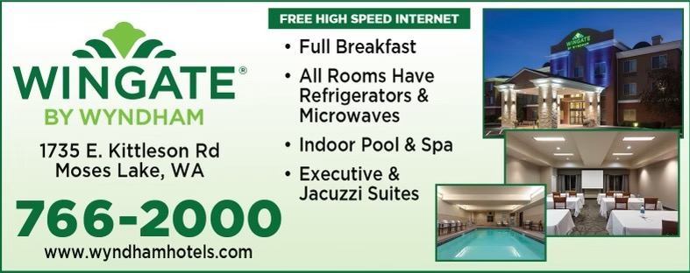

Tournament Gear: Apparel with the tournament logo will be sold by our vendor. Prices are very reasonable.

Tournament Format:

4 Team Pool Schedule
Play | Ref
1 vs 3 | 2
2 vs 4 | 1
1 vs 4 | 3
2 vs 3 | 1
3 vs 4 | 2
1 vs 2 | 4

Pools: Courts 1 & 2 are located in the High School and Court 3 is located in the Elementary school. All schools are located on the same property within walking distance. Bleachers are available in both gymnasiums.
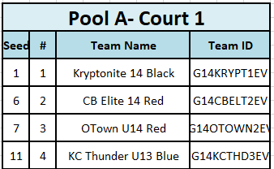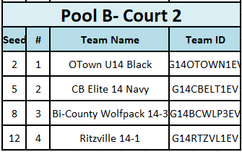

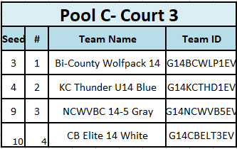

Remember to bring your Sports Engine roster! Rosters will not be provided!
Thank you so much for attending our tournament. Please let us know if you have any questions!

