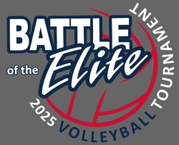
Battle of the Elite U-14
January 19, 2025
Warden School District
101 W Beck Way, Warden, WA 98857

Tournament Director: Jennifer and Michael De Hoog, 509-760-0076/509-760-5475

Times: The High School Gym will be open at 7:00 am. The coaches meeting will be at 7:30 am in the high school gym foyer. Play for 4 team pools will begin at 8:00 am. All matches will be best of 3 no cap.

The Elementary School gym will open at 8 am. Coaches meeting will be at 8:30 play for 3 team pools will begin at 9 am. All matches will play 3 sets to 25 points no cap. There will be a 45 min break for lunch between the second and third match.

Pool Play: Warm-ups for the first two rounds will be five minutes and three minutes for the remaining rounds. Serving must be included within your warm-up time. We do ask that we keep the pace of play moving, but please use discretion. Number 1 seeds in the four team pools do not have a break from playing and officiating until the fifth round of pool play.

Bracket Play: Play will begin shortly after pool play is finished and the brackets are set. Sets will be best of three (25/25/15) with no cap. First and second place teams from each pool will go to the Gold bracket and third and fourth place teams will go the Silver bracket. Check in with tournament director before leaving to secure that all officiating assignments are covered. You are required to officiate the following match if you lose.

Team Areas: Team areas will be located in the commons of the high school across from the gym and the hallway of the elementary school for pool C. No plug-in devices (crockpots, etc.) are allowed. Any of you that have hosted tournaments understand what clean up can be like when the day is done. Please communicate with your parents and players to clean up after themselves and let myself know of any spills or special clean up needed so we can take care of the facility and leave it better than we found it. No food is allowed on the courts or at the scorer’s table. Water only at the benches. Covered drinks will be allowed in the stands. Please notify us immediately if a spill should occur.

Tournament Amenities: Although the tournament is in Warden, if you need a hotel, you will want to stay in Moses Lake. We recommend Wingate and booking information was sent out in an earlier email. Warden’s coffee stand, Casita De Café, is willing to be open from 7-12 on Sunday for our tournament. Please support this local business. (120 N. County Rd Warden, WA 98857)

Tournament Gear: Apparel with the tournament logo will be sold by our vendor.

Tournament Format:

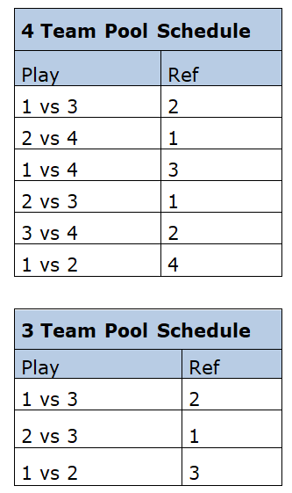
Pools A & B: Courts 1 & 2 are located in the High School.

Pool A Warden HS
Seed | # | Team Name | Team ID
1 | 1 | CB Elite 14 Navy | G14CBELT1EV
6 | 2 | OTown U14 Black | G14OTOWN1EV
7 | 3 | NCWVBC 14-5 Gray | G14NCWVB5EV
11 | 4 | Club ZZU Potlach A | G14CBZZU5EV

Pool B Warden HS
Seed | # | Team Name | Team ID
2 | 1 | UVC 14 | G14UPRVB1EV
5 | 2 | CB Elite 14 Red | G14CBELT2EV
8 | 3 | OTown 14 Red | G14OTOWN2EV
10 | 4 | NCWVBC 14-6 Blue | G14NCWVB6EV

Pool C: Court #3 is located at the Elementary school which is walking distance from the HS.

Pool C Warden Elementary
Seed | # | Team Name | Team ID
3 | 1 | Kryptonite 14 Black | G14KRYPT1EV
4 | 2 | Sky U13 Power | G13SPSKY1EV
9 | 3 | CB Elite 14 White | G14CBELT3EV

Remember to bring your official USAV roster! Rosters will not be provided!

Thank you so much for attending our tournament. Please let us know if you have any questions!

