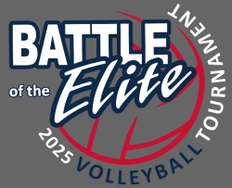

Battle of the Elite Boys
Location: | Big Bend Community College Gymnasium  7662 Chanute St. Bldg 2000
Date: | February 9, 2025
Time: | 7:15 doors open
Directors: | Alexa Moser  Jen De Hoog

Times:
Gyms will be open at 7:15 am. Coaches meeting will be at 7:30 am.
Pool Play will begin play at 8:00 am.

Pool Play:
Pool Play will play best of three sets to 25 no cap. Third set to 15 with no cap.
Warm-ups for the first two rounds will be five minutes and three minutes for the remaining rounds. Serving must be included within your warm-up time. We will have a 45min lunch break between the 3rd and 4th round of pool play.

Play will conclude after the final round of pool play as all teams will have played each other. Each team will play 4 games and ref 1 game. Please note that the officiating team will be officiating 2 courts at the same time. CB Elite will attempt to provide assistance with score keeping, libero tracking and score flipping. Coaches will need to R1, players will need to R2 and line judge on both courts. If you do not have an assistant coach available to R1 the second court, please let us know and we will provide an R1. See the attached play schedule for more information.

Team Areas/Fans:
The team area will be designated to the North Mezzanine (above Court 2). WRESTLING MATS OFF LIMITS and NO crockpots/slow cookers etc.
Designated seating area for fans will be on the balcony above courts 1 and 2, and on areas that are carpeted on gym floor ONLY. There will be standing room above court 1 on the South Mezzanine but WRESTLING MATS ARE OFF LIMITS.
Small warm-up area for teams will be located in the back court but NO balls.
Any of you that have hosted tournaments understand what clean up can be like when the day is done. Please communicate with your parents and players to clean up after themselves and let myself know of any spills or special clean up needed so we can take care of the facility and leave it better than we found it.
No food allowed is on the courts or at the score/ref table. Water only at the benches.
Remember to bring your official USAV roster! Rosters will not be provided!

Thank you so much for attending our tournament. Please let me know if you have any questions!
Play Format:
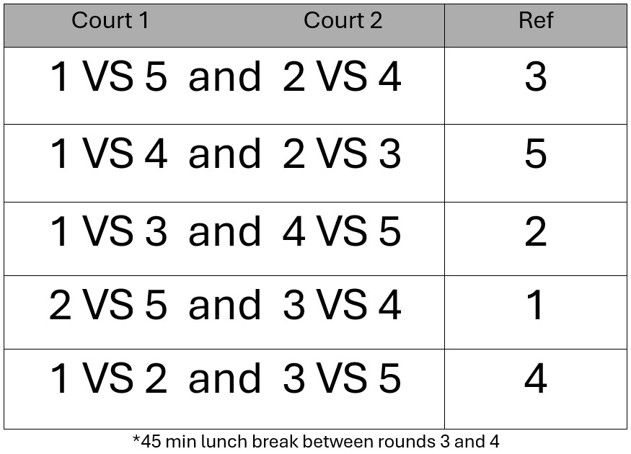
Teams:
- NCWVBV 18-1 Gold
- CB Elite 18 Navy
- NIVBC 18 Luke
- NCWVBC 18-2 Black
- CB Elite 18 Red

