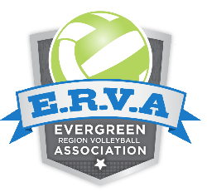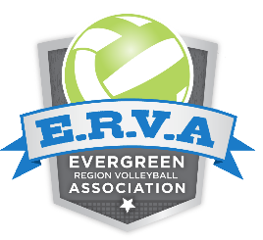**ERVA Region**

**Offer and Acceptance Agreement**

For the 2020-2021 season, this letter is to certify that I am joining the below club and team for the 2020-2021 USAV Membership period. (Athlete’s Name)

|  |  |
| --- | --- |
| _________________________ | **$** |
| **Region Club Name** | **Team Name** - Must Be Entered for **Age Group Offered**  **Initial Installment**  Offer to be recognized by ERVA |
| Date of Offer: ___/____/___  Time of Offer: ___________ | ***Once this written offer is made, the offer MUST stay valid for 72 hours from the date/time listed before a club may rescind. Offers can be extended past the 72 hour period at the discretion of the club.*** |

Once this offer is signed and fully executed by all parties all other clubs are obligated to respect my signing and shall cease to contact me. I shall notify any club coach, club representative or club director who contacts my family or me that I have officially joined the above-mentioned club. Signatures by the player, guardian and club director of this letter of intent and payment of initial installment signifies commitment to the CLUB for one season. **It is unethical to attend another club’s tryout or discuss other opportunities once you have fully executed this agreement.**

Club contracts may accompany or follow this form; club contracts are not administered nor the responsibility of the ERVA. Club Contracts may require a minimum deposit, future payment schedule, financial commitments, player expectations and define potential release from contract procedures. The club contract is between the player/parents/guardians and the club. Please read thoroughly and understand the contract and commitment you are making on behalf of your daughter to the club.

Prior to the **Tryout/Offer Start Date**, a club (all representatives for a club) is prohibited from presenting/accepting any written offer, and/or accepting any payment for any club dues associated with USAV membership for the upcoming season.

**Tryout/Offer Date** – first date that any official written offer to play in the upcoming USA Volleyball membership season may be offered to players

**Acknowledgement Date** - Once an official offer has been made to the player, the club must leave the offer on the table (the club may not rescind an offer) for 72 hours following the Offer Date and Time listed. The player may accept the written agreement before the 72-hour period has expired if they so choose. The purpose for the Acceptance Window is to allow players to leave the club’s gym without the pressure of losing their offer.

**Dead Period**- A club may not present a player with an official Offer and Acceptance Agreement prior to the first day of the ERVA Tryout and Offer Start Dates

**Tryout and Offer Start Dates**

|  |  |  |
| --- | --- | --- |
| **Age Group** | **2020-2021 First Day/Last Day to Tryout/ Offer** | **Acceptance Window** |
| U12-U18 | September 12, 2020 | 72 Hours from Official Offer |

**Recognition of Club Affiliation** - After accepting an offer from a club, the player is to update their “Club Affiliation” in MMS to show the club with which they are to be affiliated for the upcoming season. The region will use both the “Online Club Affiliation” and this Agreement to settle and disputes regarding club affiliation.

We the undersigned jointly certify that we have read and understand the above information and agree to be bound to the above club for the current junior sanctioned indoor season as defined by the end of the ERVA Participant’s Handbook.

Date:

Athlete/Participant (Print Name) Athlete/Participant (Signature)

Date:

Parent/ Guardian (Print Name) Parent/ Guardian (Signature)

Date:

Club Director (Print Name) Club Director (Signature)

**If you feel that you were pressured into signing this form and were not given the opportunity to tryout at another club, please contact the Evergreen Region office immediately at** **office@evergreenregion.org**