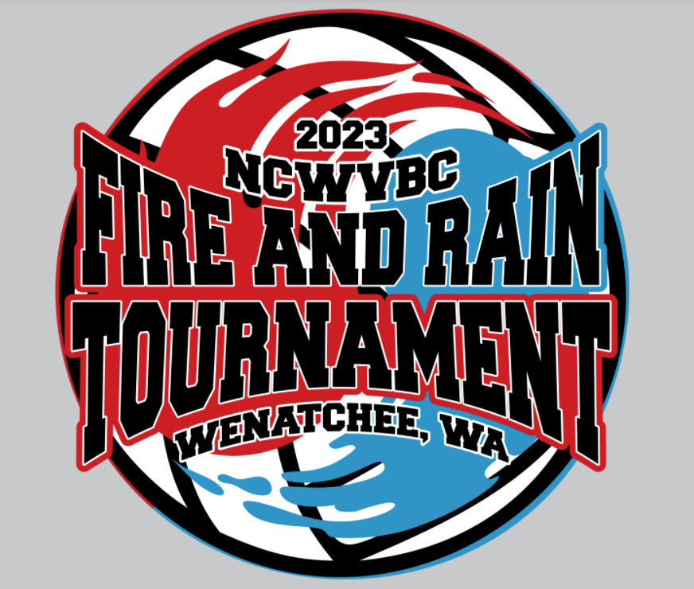

#### ****NCWVBC fire & rain U12 – SATURDAY, February 11, 2023****

[**Eastmont Jr High School, 905 8th St NE, East Wenatchee, WA**](https://www.google.com/maps/place/Eastmont+Junior+High+School/@47.4181144,-120.2754054,17z/data=!3m1!4b1!4m5!3m4!1s0x549bccface2840a3:0xbb2e47d7dd9366b6!8m2!3d47.4181075!4d-120.2731663) **(3 Courts)**

[**Clovis Point Elementary, 1855 4th St SE, East Wenatchee, WA**](https://www.google.com/maps/place/Clovis+Point+Elementary+School/@47.3998307,-120.258143,17z/data=!3m1!4b1!4m5!3m4!1s0x549bcd0a336fc625:0xdde3977e7ee3645f!8m2!3d47.399831!4d-120.2565195) **(2 Courts)**

[U-12 Pool & Schedule Information](https://ncwvbc.com/2023-fire-rain/)**(click on the blue link or Rt click and copy link)**

The sites are within about a mile of one another so we get to bracket play and there is movement between the gyms it will be an easy move between the sites. There will be areas where the players can put their things while they are playing

There is limited seating available. **Please** follow posted rules regarding food and beverage in the gyms.  No outlet usage for cooking devices.

Children must always be supervised. Please do not leave children unattended. We have many glass trophy cases and large photo frames in many of the hallways; PLEASE no bouncing or hitting balls outside the gym.

The gyms will open at 7am. There will be a coaches’ meeting at 7:30am and play will begin at 8am. Warm-ups will be 5 minutes and 5 minutes for the first two matches of each pool and 3 and 3 for the remaining pool and bracket matches. There will be no shared serving, but we will not switch sides between sets. HOWEVER, we will shake hands (bump fists, whatever) under the net at the conclusion of each match.

We will keep all gyms results updated at each site so you will be able to follow the pool play. We will have one day official at each site.  There will be site directors at each site running the coaches meeting, recording pool play and answering questions as they arise.

Tournament apparel (t-shirts, sweatshirts, etc.) will be available at Eastmont Junior High School on Saturday and Sunday.

**One quick note—please be sure that there is no cell phone (or other electronic device) use at the scorer tables**

We look forward to seeing you all Saturday. If there are any questions please do not hesitate to contact me.

