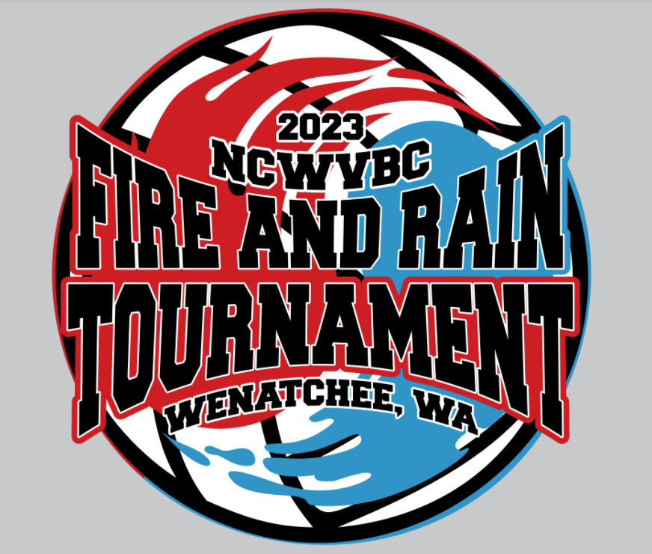

#### ****NCWVBC fire & rain U18 TOURNAMENT****

#### ****SUNDAY, February 12, 2023****

Wenatchee High School, 1101 Millerdale Ave, Wenatchee, WA

**U-18 Pool & Schedule Information** (click on the blue link or Rt click and copy link)

Thanks for your entry into the tournament on Sunday in Wenatchee. All U18 matches will be played at Wenatchee High School.

There is bleacher seating available in both gyms. There will be no outlet usage for cooking devices.

Children must always be supervised. Please do not leave children unattended. We have many glass trophy cases and large photo frames in the hallways; no bouncing or hitting balls outside the gym.

The gym will open at 7am. There will be a coaches’ meeting at 7:30am and play will begin at 8am. Warm ups will be 5 minutes and 5 minutes for the first two matches of each pool and 3 and 3 for the remaining pool and bracket matches. There will be no shared serving and we will not switch sides between sets. HOWEVER, we will shake hands (bump fists, whatever) under the net at the conclusion of each match.

We will keep all gyms results updated at each site so you will be able to follow the pool play. There will be site directors at each site running the coaches meeting, recording pool play and answering questions as they arise.

Tournament apparel (t-shirts, sweatshirts, etc.) will be available at Eastmont Junior High School.

**One other quick note: Please be sure that there is no cell phone (or other electronic device) use at the scorer tables.**

We look forward to seeing you all Sunday. If there are any questions please do not hesitate to contact me.

